Fresh Start - Assessment and grouping

Assessment

Identify the right pupils for Fresh Start
In primary schools, assess all pupils in Years 5 and 6 (P6 & P7) who are reading below national expectations.

In secondary schools, assess students who did not meet national expectations at the end of KS2 and older struggling readers*.

Ensure consistent assessments

One teacher should carry out all the assessments.
In a large school, you might want to enlist the help of another teacher or HLTA.
Agree how to annotate the assessments.
Moderate your judgements by:
- working together to assess a few pupils
- completing the Fresh Start School Assessment Record together to group pupils working at the same challenge point.

Assess the pupils

Download from the School Portal:
- Assessment Pupil Sheet - one copy of the assessment for each person carrying out the assessment
- Individual Assessment Record – one for each pupil
- Individual Progress Record (IPR) – one for each pupil
- School Assessment Record
- Pupil Progress Tracker.

Before you start, read the assessment instructions on the Individual Assessment Record.

- Ask the pupil to read the Assessment Pupil Sheet.

- Use one Individual Assessment Record for each pupil. Mark off the sounds, words and passages they can read and then determine their starting point.

- Count how many pupils are at the same challenge point and record on the School Assessment Record ready to group pupils.

- Transfer each pupil's starting point to the Individual Progress Record (IPR). Share with the tutor so they know what to teach. They will use the IPR to highlight the sounds, words and module that the pupil has learnt to read each week.

- Complete the Pupil Progress Tracker. Date the column corresponding to each pupil's assessment outcome to track individual progress.

- Repeat this process to assess and group pupils every half-term.

Grouping

Teach pupils who assess below Module 14 one-to-one.
If this is not possible, teach pupils at the same challenge point in small groups (4 or fewer).

Teach pupils in groups if they are reading Module 14 onwards – only if they are reading the same Module.
You may want to teach for up to one hour a day if more than 4 pupils in a group.

*Older struggling readers

If pupils’ reading is below what is expected for their age, it is important to determine whether they have difficulty with word reading (decoding), language comprehension or both of these, since different kinds of teaching are needed for each. The Simple View of Reading (below) can be useful when thinking about children’s reading difficulties and where they might lie in terms of three of the four quadrants.

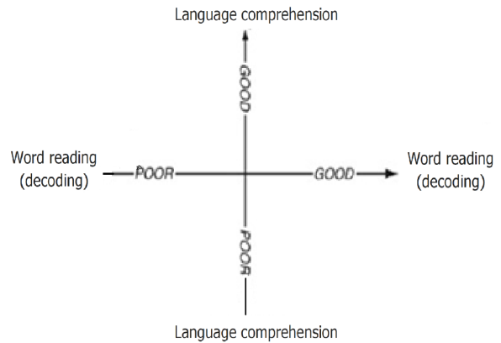

Fresh Start accelerates reading progress for pupils who have good comprehension but poor word reading (the top left-hand quadrant), and those who have poor comprehension and poor word reading (the bottom left-hand quadrant).

Fresh Start is not for pupils who have difficulty understanding what they have decoded, but have good word reading skills (the bottom right-hand quadrant).

Instead, these pupils will benefit from teachers reading aloud every day to enhance their enjoyment of literature, increase their vocabulary and develop their language comprehension.

These pupils should read often, in English lessons and across the curriculum: to learn from their reading, to read for pleasure and for specific purposes, and – with practice – to become more fluent, since fluency is important for comprehension.

